**SAP FICO**

(Finance and Controlling)

|  |
| --- |
| **TECH VISION**  **IT TRAINING AND PLACEMENT SERVICES**  [**www.techvisionit.com**](http://www.techvisionit.com) |

**Course Duration:** 60 hours

**Sessions:** Weekdays; Weekends; Crash Course

**Course Summary:**

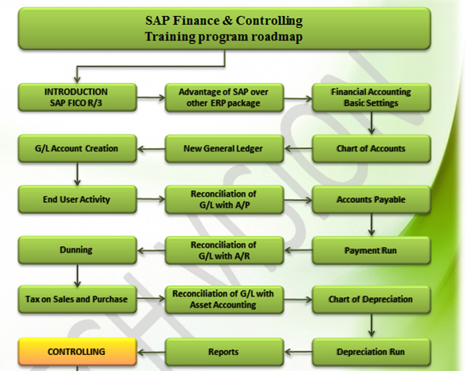

**Introduction to SAP R/3**

* Introduction to ERP, Advantages of SAP over other ERP Packages
* Introduction to SAP R/3 FICO

**Organizational Structure and Global Parameters:**

|  |
| --- |
| * Define Company Code |
| * Define Company and assign to Company Code |
| * Define Business Area |
| * Define Credit Control Area |
| * Maintain Controlling Area |
| * Assign Company Codes to Controlling Area |
| * Maintain Company Code Global Parameters |
| * Set company Code Productive |
| * Maintain Fiscal Year Variant |
| * Assign Fiscal Year Variant to Company Code |
| * Define Posting Period Variant |
| * Maintain Open and Close Posting Periods |
| * Assign Posting Period Variant to Company Code |
| * Define Field Status Variant |
| * Assign Field Status Variant to Company Code |
| * Define Document Types for Postings |
| * Define Number Ranges for Document Types |
| * Define Tolerance Groups for employees |
| * Assign Tolerance Groups |
| * Set Fiscal year Default for Company Code Set Default Value date Propose for Company Code |
| * Check and Assign Tax Calculation Procedure to Country |
| * Define Tax Codes for Sales and Purchases |
| * Define Tax Accounts for Postings |
| * Activate Extended Withholding Tax |
| * Define Withholding Tax Types for Invoice and Payment Postings |
| * Define Withholding Tax codes |
| * Assign Withholding Tax Types to Company Codes |
| * Define Accounts for Withholding Tax Postings |

**General Ledger Accounting**

* Creation of General Ledger Master (with and without reference)
* Display/Change/Block/Unblock of general ledger master
* Document Entry posting normal postings and posting with reference
* Display and change of documents
* Display of GL balances
* Display GL account line items
* Parked documents
* Hold documents
* Creation of Sample Document and postings with sample documents
* Defining recurring entry document and postings with recurring doc
* Creation of account assignment model and posting
* Configuration of line layouts for display of GL line items
* Reversal of individual documents, mass reversal, reversal of cleared items and reversal of accrual and deferral documents
* Defining Exchange Rate types and Translation ratios
* Define Exchange rates & posting of foreign currency transactions
* Interest calculations on term loans
* Accrual and Deferral documents

**Accounts Payable**

* Creation of vendor account groups
* Creation of number ranges for vendor master records
* Assignment of number ranges to vendor account groups
* Creation of tolerance group for venders
* Creation of vendor master (display/change/block/unblock of vender master)
* Posting of vendor transactions (invoice posting, payment posting, credit memo)
* Settings for advance payments to parties (down payment) and clearing of down payment against invoices (special GL transactions)
* Posting of partial Payment & Residual Payment
* Creation of payment terms,
* Creation of house banks and account ids
* Creation of check lots and maintenance of check register
* Display check register
* Cancellation of UN issued checks
* Creation of void reasons
* Cancellation of issued checks
* Posting of purchase returns
* Configuration of automatic payment program
* Payment to vendors through APP
* Defining correspondence & party statement of accounts

**Accounts receivable**

* Creation of customer account groups
* Creation of number ranges for customer master records
* Assignment of number ranges for customer account groups
* Creation of tolerance group for customers
* Creation of customer master (display/change/block/unblock of vender master)
* Posting of customer transactions (sales invoice posting, payment posting, debit memo)
* Settings for advance payment from parties (down payment)
* Configuration of settings for dunning
* Generating the dunning letters
* Defining correspondence and party statement of accounts
* Bills of exchange
* Posting of sales returns

**Asset Accounting**

* Defining chart of depreciation
* Creation of % tax codes for sales and purchased
* Assignment of chart of depreciation to company code
* Defining account determination
* Definition of screen lay out rules
* Definition of number ranges for asset classes
* Integration with General Ledger & Posting rules
* Defining Depreciation key
* Definition of multilevel methods
* Definition of period control methods
* Creation of main asset master records
* Creation of sub asset master records
* Acquisition of fixed assets
* Sale of fixed assets
* Transfer of assets
* Scrapping of assets
* Depreciation run
* Line item Settlement of assets under construction of capital work in progress

**New General ledger accounting**

* Parallel ledgers
* Document splitting
* Segments

**Reports**

* Financial statement version
* General Ledger, Accounts Payable, Accounts Receivable and Assets Reports

**Controlling**

**Basic settings for controlling**

* Defining Controlling Area
* Defining Number ranges for Controlling Area
* Maintain Planning Versions

**Cost element accounting**

* Creation of primary cost elements from financial accounting area
* Creation of primary cost elements from controlling area
* Display of cost element master records
* Change cost element master records
* Primary cost element categories
* Secondary cost element categories
* Default account assignments

**Cost Center Accounting**

* Defining Cost Center Standard Hierarchy
* Creation of Cost Centers and cost center groups
* Display cost center master records
* Change cost center master records
* Creation of cost center groups
* Posting to cost centers
* Reposting of co line items
* Repost of Costs
* Planning for cost centers
* Overhead Calculation
* Creation of secondary cost element master records
* Creation and Execution of Distribution Cycle
* Creation and execution of assessment cycles
* Cost center reports